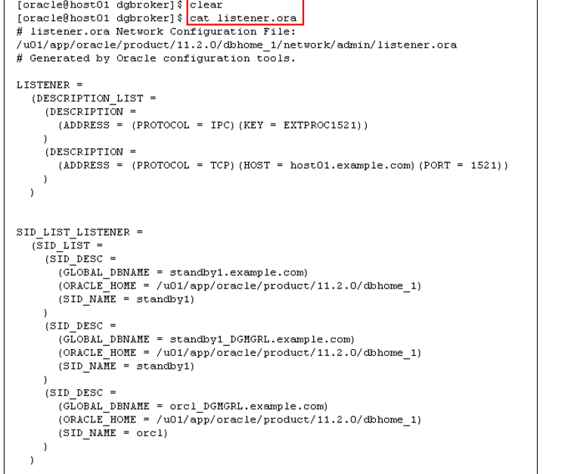

To enable DGMGRL to restart instances during the course of broker operations, a service with a specific name must be statically registered with the local listener of each instance. The value for the GLOBAL_DBNAME attribute must be set to a concatenation of <db_unique_name>_DGMGRL.<db_domain>.

Examine the listener.ora file in $HOME/wkdir/dg_broker, and then examin $ORACLE_HOME/network/admin/listener.ora. Note in particular the SID list entries for standby1_DGMGRL and orcl_DGMGRL. Replace $ORACLE_HOME/network/admin/listener.ora with $HOME/wkdir/dg_broker/listener.